**FINAL ASSIGNMENT**

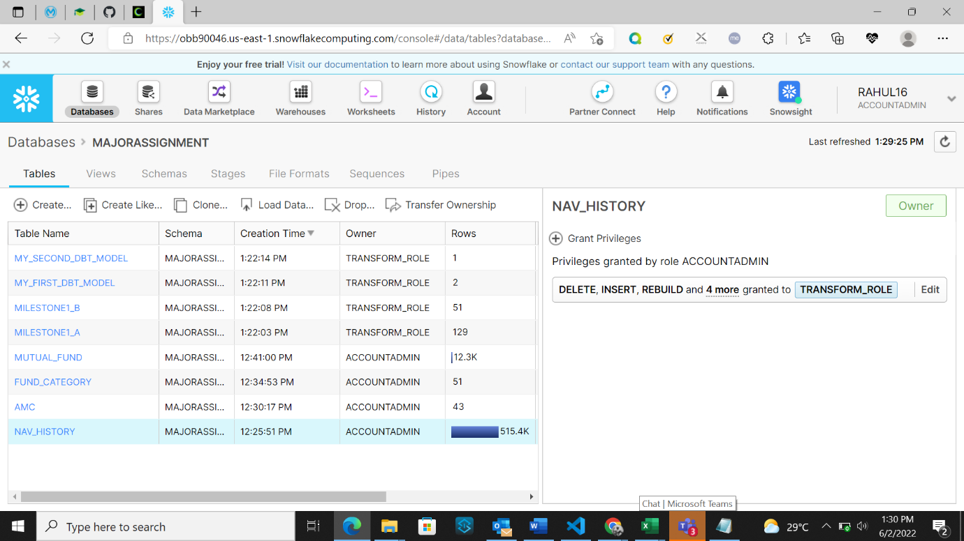

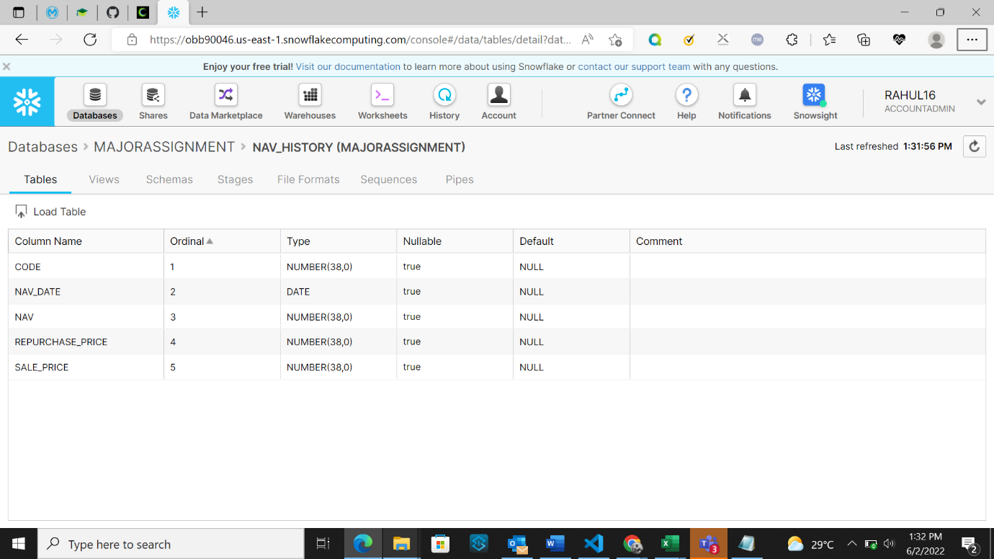

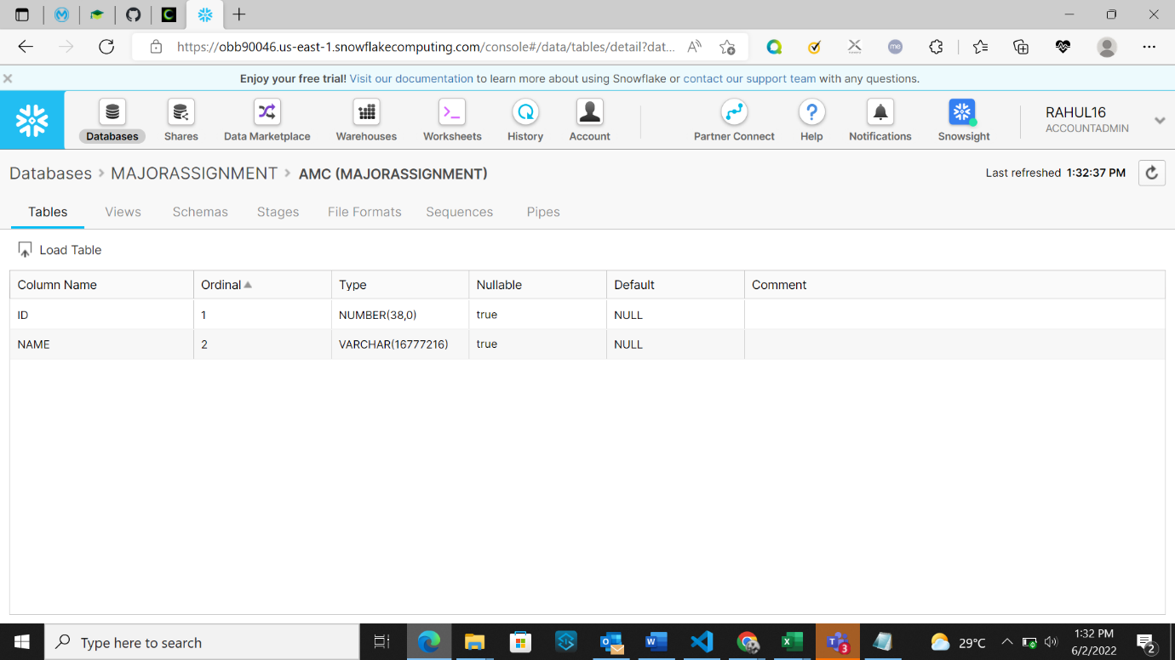

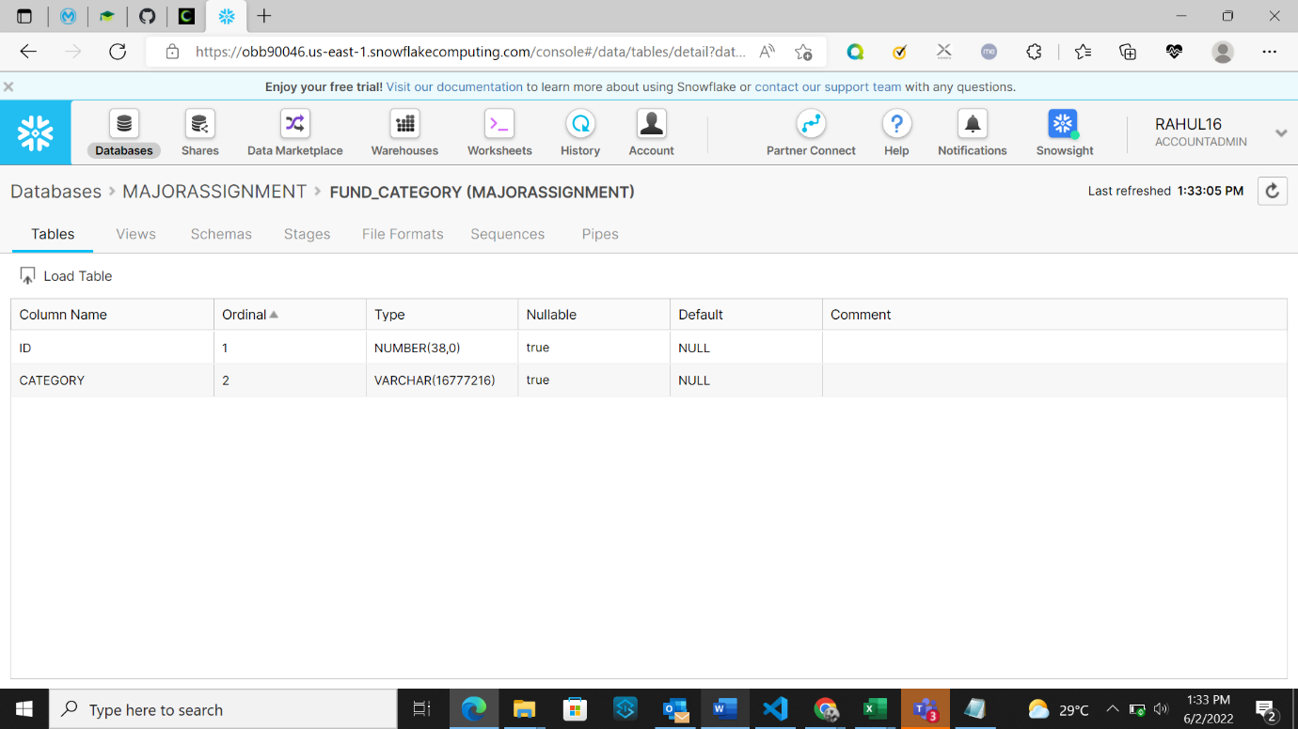

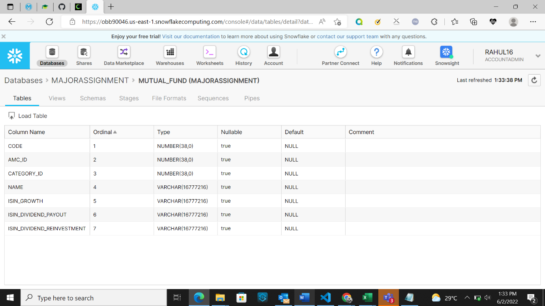

**Milestone-1 :**

**Gather basic data insights from the given data**

* 1. Calculate Monthly average NAV, Repurchase & Sale Price for each scheme.

select f.category,month(nav_date) as mon,avg(nav) as avg_nav,avg(repurchase_price) as avg_repur_price,avg(sale_price) as avg_sale_price

FROM

"MAJORASSIGNMENT"."MAJORASSIGNMENT"."NAV_HISTORY" n join "MAJORASSIGNMENT"."MAJORASSIGNMENT"."MUTUAL_FUND" m

on n.code=m.code join "MAJORASSIGNMENT"."MAJORASSIGNMENT"."FUND_CATEGORY" f

on m.category_id=f.id group by f.category,mon order by f.category,mon;

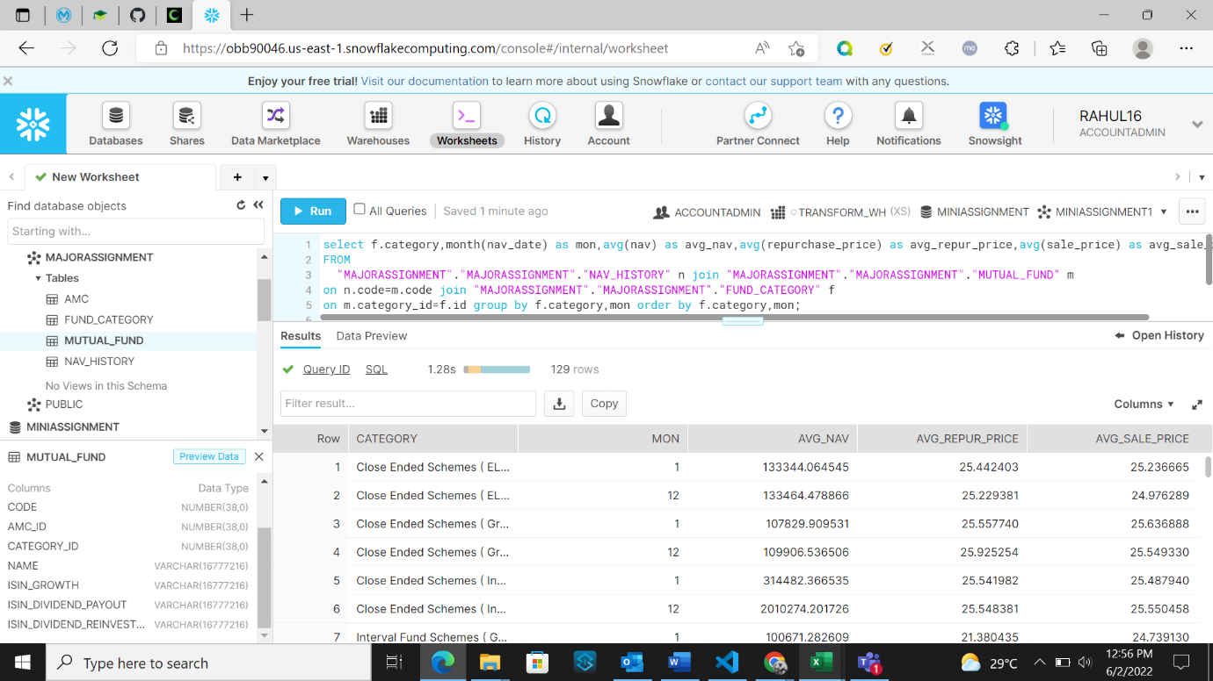

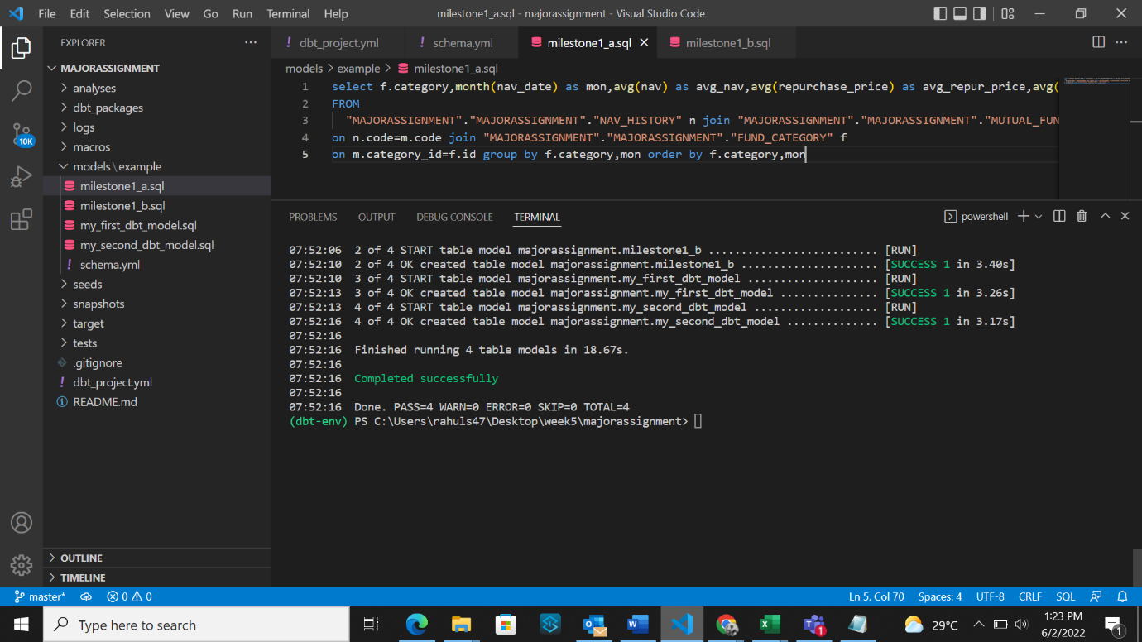

* 1. Find out each scheme’s Max and Min NAV value and Date it occurred

WITH Cte AS

(

SELECT nav_date,f.category as category,nav,

ROW_NUMBER() OVER(partition by f.category ORDER BY nav ASC) RN1,

ROW_NUMBER() OVER(partition by f.category ORDER BY nav DESC) RN2

FROM

"MAJORASSIGNMENT"."MAJORASSIGNMENT"."NAV_HISTORY" n join "MAJORASSIGNMENT"."MAJORASSIGNMENT"."MUTUAL_FUND" m

on n.code=m.code join "MAJORASSIGNMENT"."MAJORASSIGNMENT"."FUND_CATEGORY" f

on m.category_id=f.id

)

SELECT category,

MAX(CASE WHEN RN2=1 THEN nav END) maxnav,

MAX(CASE WHEN RN2=1 THEN nav_date END) maxnavdate,

MAX(CASE WHEN RN1=1 THEN nav END) minnav,

MAX(CASE WHEN RN1=1 THEN nav_date END) minnavdate

FROM CTE WHERE RN1=1 OR RN2=1

GROUP BY category;

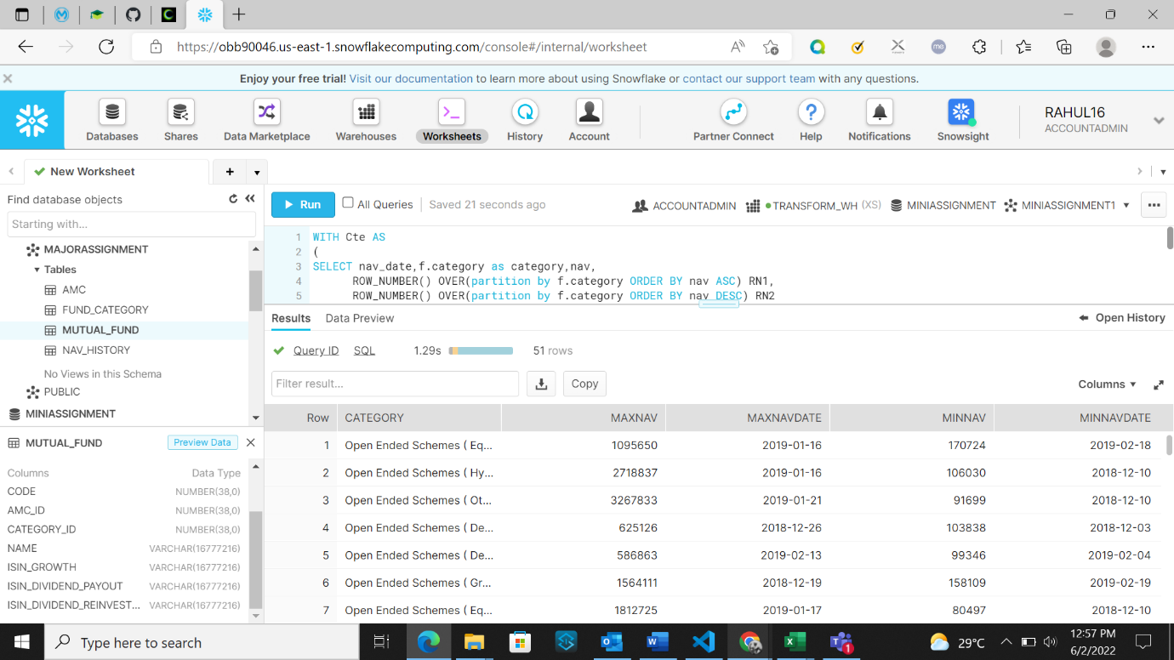

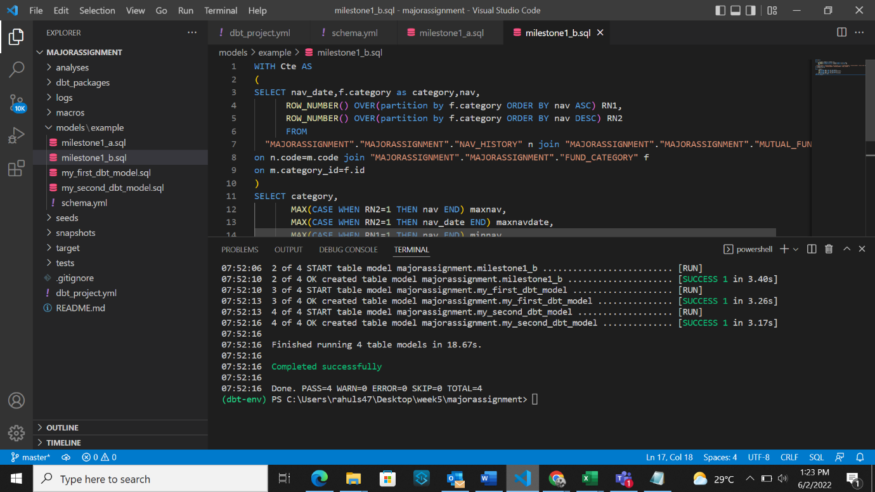

**Milestone-2 :**

**Run the following analytic queries on the data present to gain insight about the business problems :**

1. Simple: Mutual fund performance - including YTD, MTD, 1 Year and Since Inception returns. See the PPT for formula to calculate this
2. Simple: Plot performance of upto 3 funds for the past 3 months
3. Medium: List of mutual funds which were discontinued in a given year
4. Medium: Weekly, monthly and ytd results for all funds in liquid fund category
5. Medium: Best and worst performing fund in a given category on the basis of 1 year returns
6. Complex: Plot difference in returns between regular growth and direct growth plans of the same mutual fund over a 5 year period, assuming the same amount was invested in both plans 5 years ago. Aka how much commission did you pay to your broker because of regular plan

*Reference info for performance calculations:* **Formulas**

YTD is year to date. It represents the percentage increase in NAV from the start of the year

* Start date is 1st Jan of that year
* End date is today
* YTD= ((NAV at end date – NAV at start date)/NAV at Start date) *100

Similarly calculate MTD (start date is 1st of that month)

For 1 year, start date will be exactly 1 year ago

For Since Inception use the earliest possible data that you have, the formula will be different – you have to use CAGR as explained in this article -

[Https://cleartax.in/s/cagr-calculator](https://cleartax.in/s/cagr-calculator)

**Milestone-3 : Visualize analytics and build dashboards via Data Studio**

Visualize the following:

1. Plot performance of upto 3 funds for the past 3 months. [line]
2. Count of mutual funds discontinued each year. [hist]
3. Distribution of latest mutual funds based on category. [pie]
4. Average growth of mutual funds based on category for past 3months.